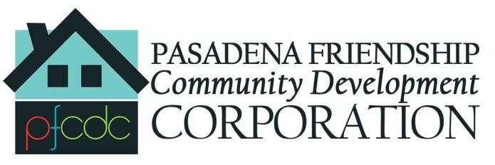



# C:\Users\Barbara\AppData\Local\Microsoft\Windows\Temporary Internet Files\Content.IE5\C7MD1S2N\mlp_paint_brush_by_pikamander2-d52v73t[1].png



First Annual Community Service Day – Altadena

In Partnership with Altadena Town Council Census Tract 4603-01

Beautification Committee, Aveson Charter School and

LA Neighborhood Housing Services

Saturday October 22, 2016

8:00AM TO 12:00 Noon

Minor Repairs, House Painting, Trash Removal, Landscaping

Some homeowners may qualify for low interest major home repair loans through LANHS

FOR MORE INFO TO VOLUNTEER & DONATIONS

Contact: [barbara@barbara-king.com](mailto:barbara@barbara-king.com)